EX1: Create a simple cloud software application for Flight Reservation System using any Cloud Service Provider to demonstrate SaaS include the necessary fields such as one way, round trip, From, to, Departure, Departure, Travelers & Class, Fare Type, International and Domestic Flights etc.

Procedure:

Step 1: Go to ZOHO.com

Step 2: Create an account and log in

Step 3: Create an application

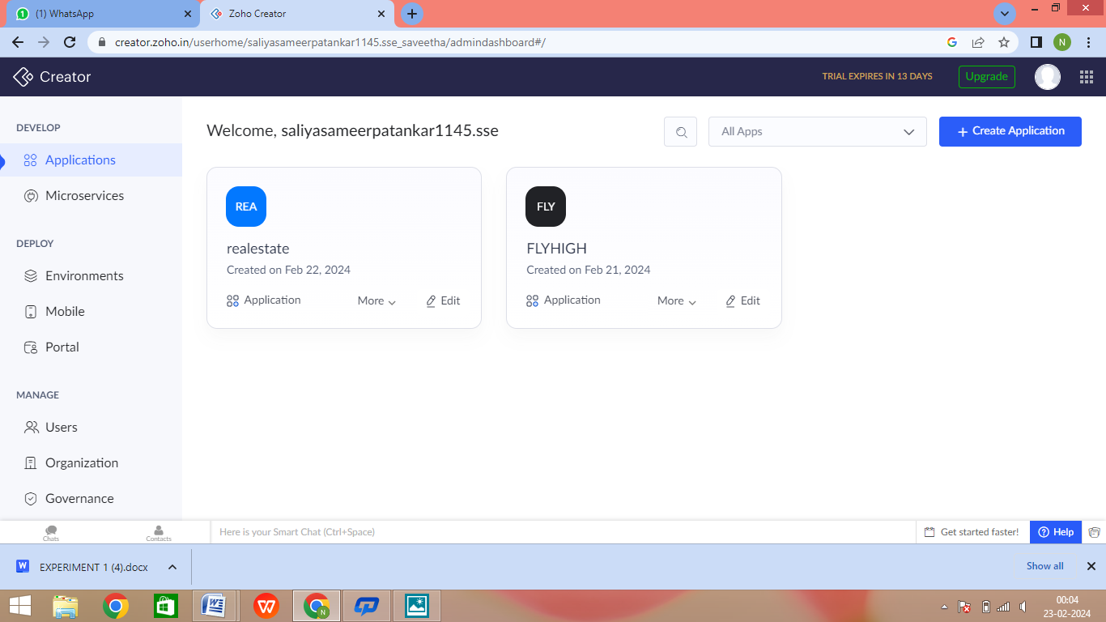

Step 4: Create login form

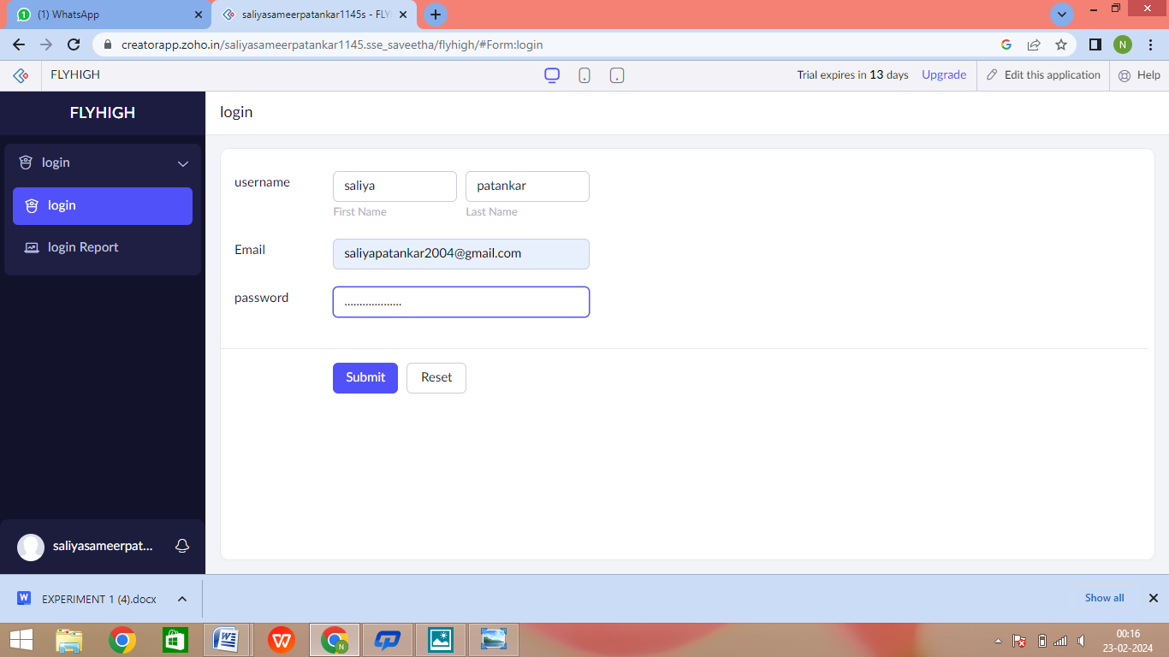

Step 5: Create the second form to get further details of travel

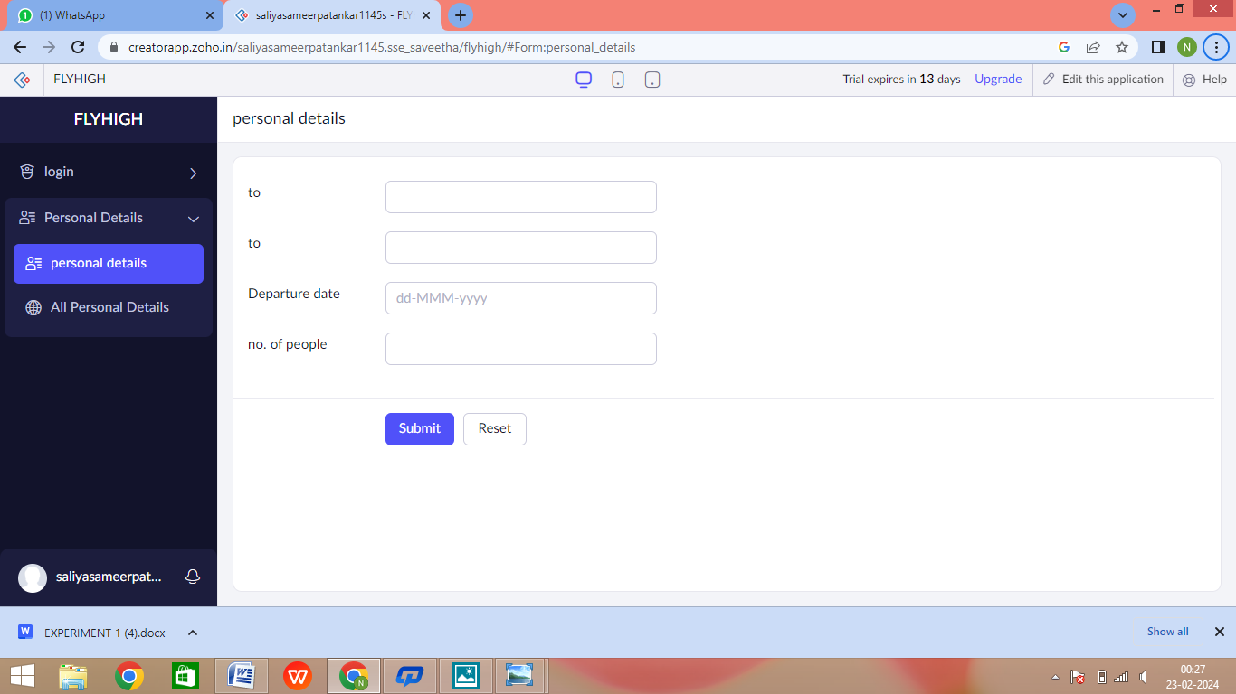

Step 6: Create third form to get details of the flight

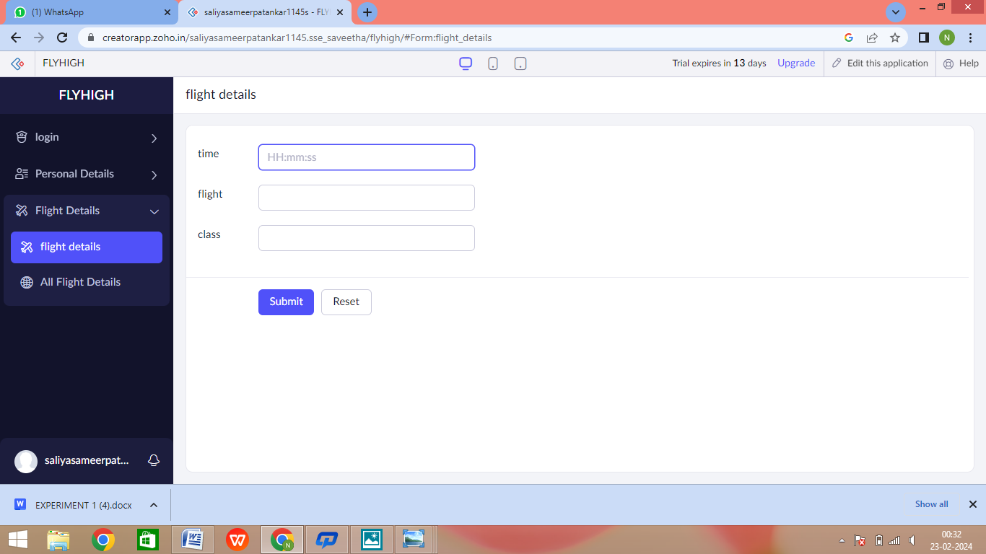

Step 7: Create Payment form

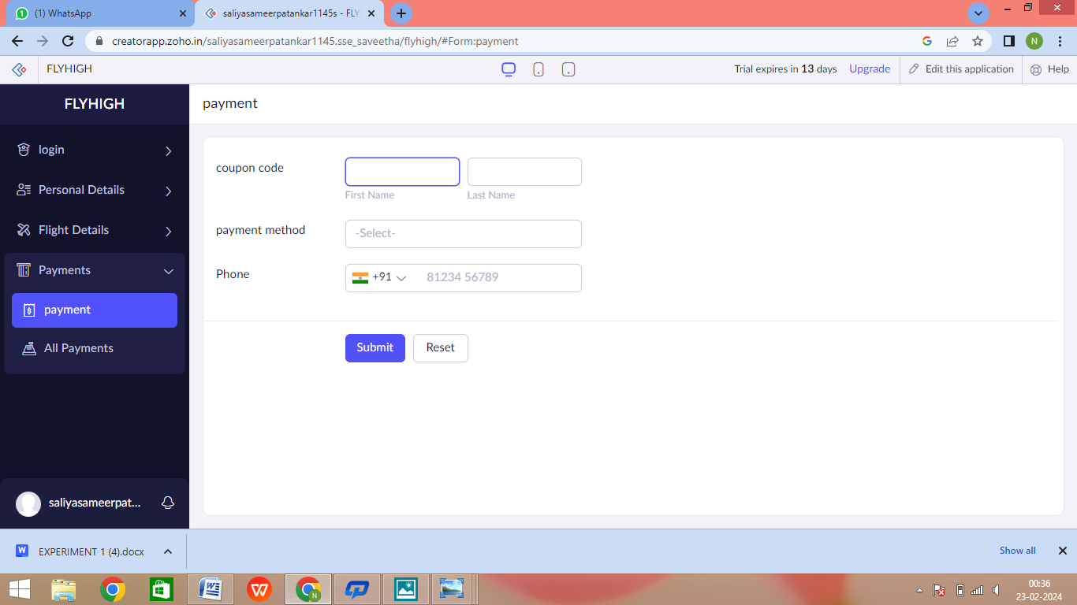

Step 8: Click the Access Development Live to see the output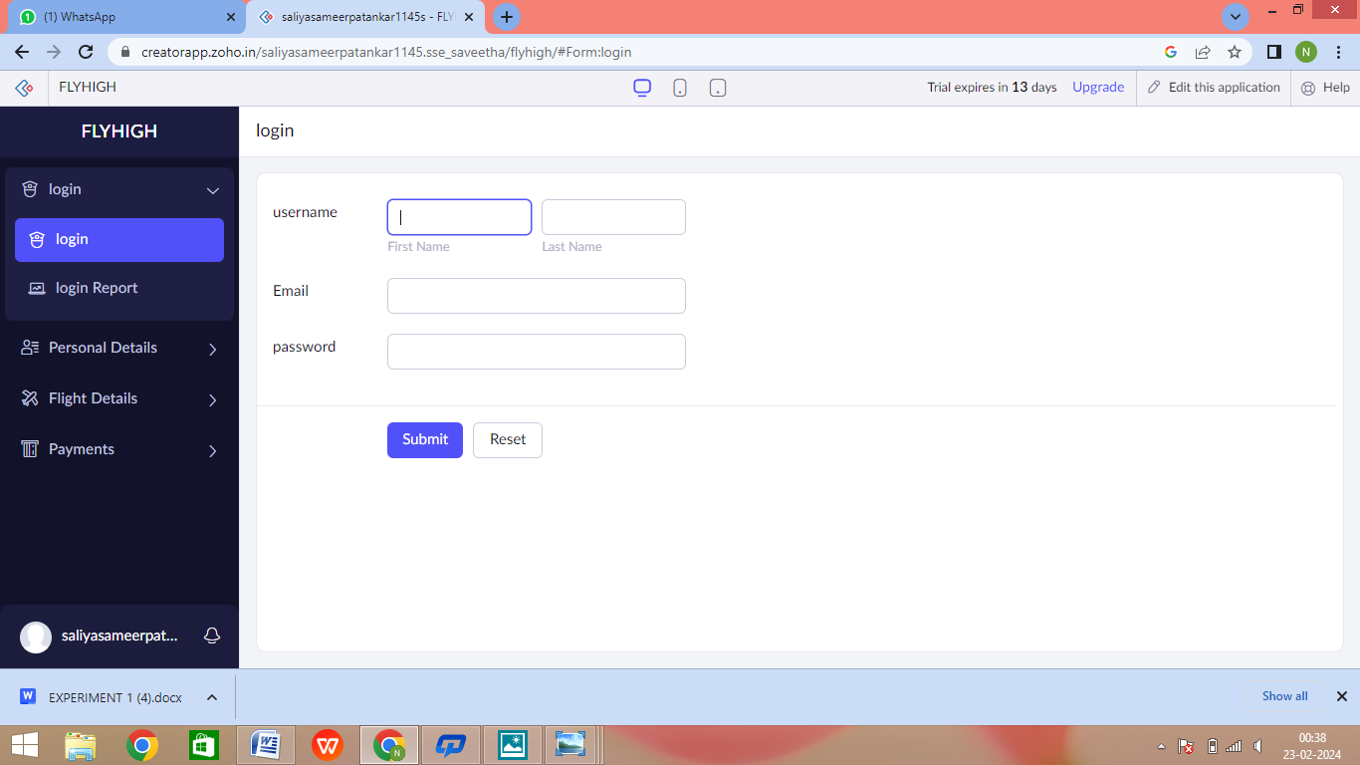

Step 9: Click the login report to see the data

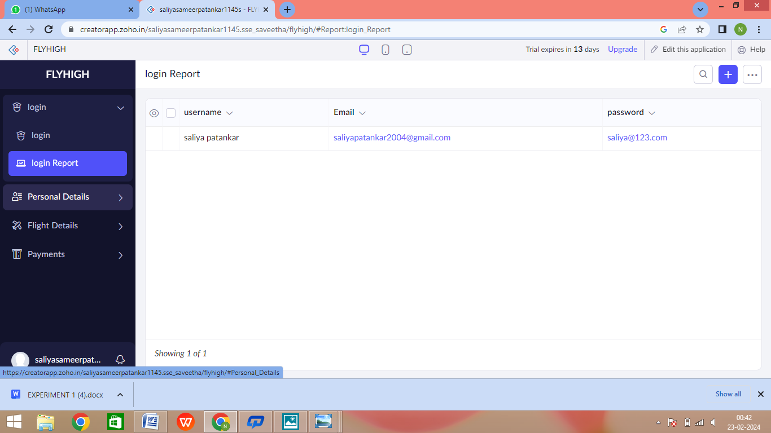

Step 10: Click on the mobile icon to see mobile output

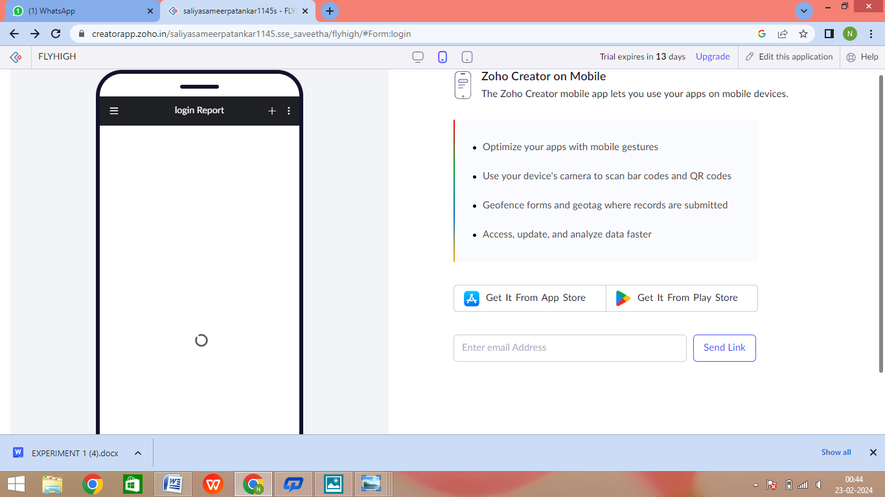

Step 11: Click on the tablet icon to see tablet output

